Explaining the Global Diffusion of Montessori Education: Economic, Social, and Institutional Drivers

Data, Measurement, and Interpretation
A natural starting point for this study is the dataset compiled by Debs et al. (2022), which provides one of the first systematic estimates of the global distribution of Montessori schools. By assembling country-level counts, their work enables comparative analysis across national contexts. At the same time, the dataset is subject to inherent limitations of decentralized and heterogeneous data collection, including varying definitions of “Montessori,” incomplete reporting, and reliance on aggregated estimates. Accordingly, the reported figures are best interpreted as approximate orders of magnitude rather than precise counts. Moreover, the degree of uncertainty is likely to scale with country size, implying substantially larger absolute deviations for large countries. In this context, apparent irregularities or unexpected patterns in the data should, in the first instance, be interpreted cautiously and may reflect reporting limitations rather than substantive differences. The reassessment of Austrian data in this study illustrates these issues and motivates a more cautious interpretation of global Montessori figures.
To complement absolute school counts, this study introduces Montessori density, defined as the number of schools per million inhabitants, as an additional dependent variable. This measure allows for more meaningful cross-country comparison by accounting for population size and capturing the relative penetration of Montessori education. In contrast to absolute counts, which span several orders of magnitude and exhibit scale-dependent uncertainty, density is bounded within a narrower range, reducing the relative impact of measurement uncertainty. While school counts remain informative for assessing overall scale and potential international influence, density provides a more robust indicator of national diffusion. Together, both measures enable a more nuanced interpretation of the global distribution of Montessori education.
To ensure the robustness and comparability of the analysis, the ranking of countries by Montessori density is restricted to countries with sufficiently large populations. Very small populations lead to instability in the denominator, as minor changes in the number of schools result in disproportionately large variations in density, limiting interpretability. Countries with small numbers of Montessori schools are retained in the dataset, but their estimates are interpreted with caution, as density values may be sensitive to small absolute changes. This approach preserves the global scope of the dataset while ensuring greater stability in the comparative analysis.

Linking Country-Level Conditions to Montessori Density

Descriptive Patterns
The distribution of Montessori school density across countries is highly right-skewed in its original scale, with most countries exhibiting low density and only a small number reaching substantially higher values. This indicates a strongly uneven global distribution.
To better understand the underlying structure, the variable is analyzed on a logarithmic scale. The log-transformed distribution is approximately unimodal and shows a roughly symmetric shape, with a peak around log10(density) ≈ 0. This corresponds to a density level of approximately one Montessori school per unit, suggesting that most countries cluster around a similar order of magnitude despite large absolute differences.
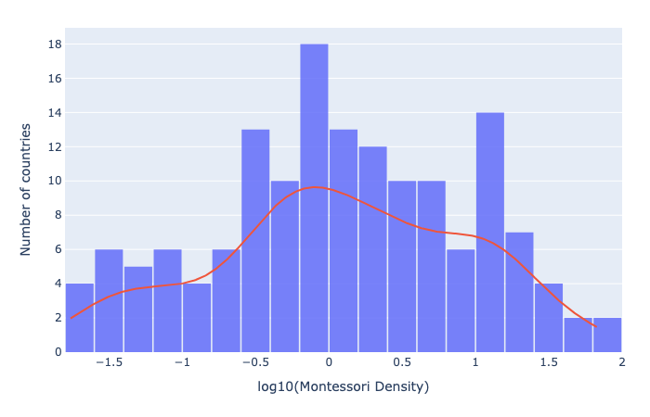
Figure 1 Distribution of Montessori school density across countries on a logarithmic scale. The near-symmetric shape supports the use of logarithmic transformations in subsequent analysis and indicates that cross-country variation is best interpreted in proportional (multiplicative) terms.
The emergence of a near-symmetric distribution in log space indicates that Montessori density follows a pattern consistent with multiplicative processes. In other words, differences between countries are better understood in proportional terms rather than absolute levels. This indicates that cross-country variation in Montessori density reflects multiplicative differences, with countries differing by orders of magnitude rather than by fixed increments. A slight right skew remains, reflecting a small number of countries with particularly high Montessori density.
Overall, the results point to substantial cross-country heterogeneity, but with an underlying structure that becomes visible when considering the distribution on a logarithmic scale.
Following table presents the top 10 countries by Montessori density for countries with a population above 500.000 inhabitants.
Rank | Country | Census | Population (Million) | Montessori Density
1 | New Zealand | 169 | 5.3 | 32.0
2 | Luxembourg | 18 | 0.7 | 26.6
3 | Norway | 130 | 5.6 | 23.3
4 | Canada | 900 | 41.3 | 21.8
5 | Latvia | 32 | 1.9 | 17.1
6 | Slovenia | 35 | 2.1 | 16.5
7 | Poland | 600 | 36.6 | 16.4
8 | Ireland | 81 | 5.4 | 15.0
9 | Thailand | 1000 | 71.7 | 14.0
10 | Switzerland | 120 | 9.0 | 13.3
Notably, only three countries from the top ten by absolute school count (Canada, Poland, and Thailand) also rank among the top ten in Montessori density, highlighting how strongly the choice of metric affects the perceived global distribution of Montessori education.
The global distribution of Montessori schools is highly concentrated: the top 11.7% of countries (18 countries) account for 80.2% of all schools worldwide, indicating that absolute counts are dominated by a small number of countries. At the same time, Montessori density varies substantially across countries, with the highest-density countries reaching levels approximately 13 times higher than a typical country. Taken together, these patterns show that Montessori education is both globally concentrated and highly uneven in its relative diffusion.
To explore how Montessori density relates to broader country-level conditions, we examine its association with a set of economic and social indicators, including GDP per capita, the Human Capital Index (HCI), and the Gini coefficient. GDP per capita serves as a proxy for overall economic development and average income levels, while the HCI captures the level and quality of education and health and thus reflects the broader capacity of a country to develop and sustain educational practices such as Montessori. The Gini coefficient measures the degree of income inequality within a country.
The analysis is exploratory and focuses on identifying patterns of association rather than causal relationships. Relationships are assessed using correlation measures, including Pearson correlation (which captures linear relationships) and Spearman correlation (which captures more general rank-based relationships and is less sensitive to extreme values).
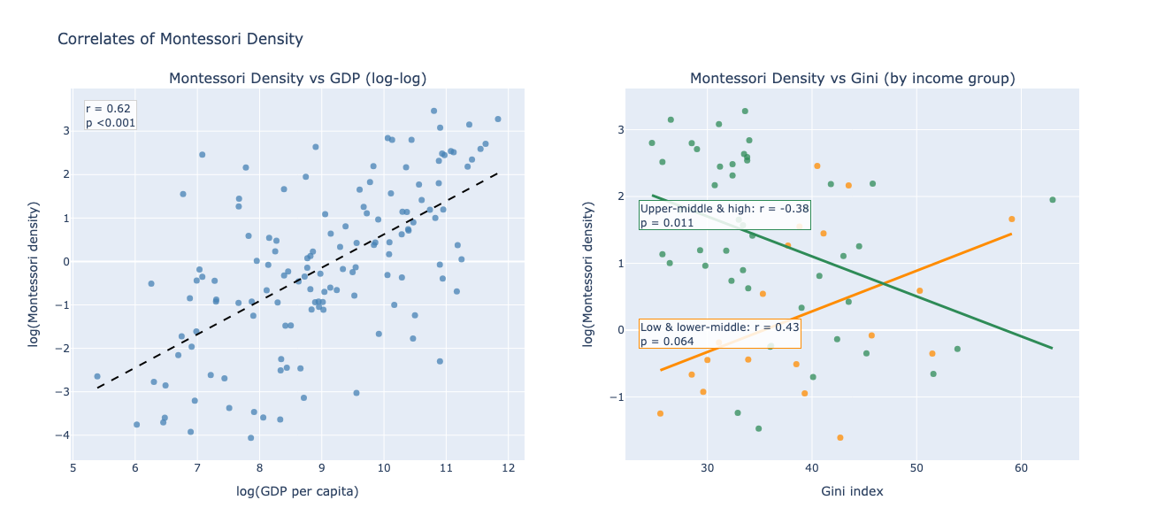
Figure 2 Associations between Montessori density and selected country-level indicators. The left panel shows a strong positive relationship between Montessori density and GDP per capita on the logarithmic scale. The right panel shows the relationship between Montessori density and income inequality for countries with at least 10 Montessori schools, separated into lower-income and higher-income groups based on World Bank income classification. The differing slopes indicate that the relationship between inequality and Montessori diffusion varies with the level of economic development.

Montessori density shows a strong and statistically significant positive association with both GDP per capita and the Human Capital Index. For GDP per capita, the correlation is approximately r ≈ 0.63 in the full sample (p < 0.001, 95% CI [0.52, 0.72]) and remains similar when excluding countries with very small Montessori presence (r ≈ 0.60). A comparable pattern is observed for the Human Capital Index (r ≈ 0.59, p < 0.001, 95% CI [0.47, 0.69]; r ≈ 0.54 in the restricted sample). These results are robust across alternative specifications and suggest that Montessori diffusion is closely linked to both economic development and broader human capital conditions.

A plausible interpretation is that higher income levels facilitate both the supply of and demand for Montessori education. Entry into Montessori provision typically requires investments in teacher training and specialized materials, which may not be locally available and therefore are not necessarily adjusted to local income levels. In such cases, both financial and time constraints can limit the ability of prospective teachers to acquire Montessori qualifications. While Montessori education is not inherently more expensive than conventional schooling, traditional systems are typically supported by the state, including training and school infrastructure, whereas Montessori provision often relies on more decentralized initiative. This creates higher effective entry barriers, particularly in lower-income contexts. At the same time, where access to schooling itself remains the primary concern, pedagogical differentiation may be of secondary importance. The strong association with the Human Capital Index further suggests that diffusion depends not only on economic resources but also on the capacity of parents and educators to access information about and engage with alternative pedagogical approaches, as well as on the broader institutional environment in which such approaches can be implemented.

The relationship between income inequality and Montessori density is not well captured by a single global coefficient. In the full sample, the correlation is weak and statistically insignificant (r ≈ -0.03, p = 0.78), indicating no systematic global association. This result, however, masks substantial heterogeneity across levels of economic development.

Using a classification based on World Bank income groups, countries can be divided into lower-income (low and lower-middle income) and higher-income (upper-middle and high income) contexts. Under this classification, the association between inequality and Montessori density differs in direction across these groups. In lower-income countries, the relationship is moderately positive (r ≈ 0.43, p ≈ 0.064, 95% CI [-0.03, 0.74]), whereas in higher-income countries it is moderately negative and statistically significant (r ≈ -0.38, p ≈ 0.011, 95% CI [-0.60, -0.09]). This pattern is consistent with exploratory analyses using alternative, data-driven GDP splits, which yield qualitatively similar results.

A plausible interpretation is that inequality plays different roles depending on the stage of economic development. In lower-income settings, a small affluent segment may enable the emergence of Montessori schools as niche institutions, leading to a positive association between inequality and Montessori presence. In higher-income settings, by contrast, broader diffusion appears to depend on the presence of a sufficiently large and capable middle class, resulting in a negative association with inequality.

Taken together, these findings suggest that the weak global relationship between inequality and Montessori diffusion reflects the aggregation of fundamentally different underlying dynamics across development levels. The role of inequality is therefore best understood as context-dependent rather than governed by a single global pattern.

Additional variables were explored to assess whether Montessori diffusion is associated with broader structural or cultural factors beyond economic and educational conditions. In particular, Google Trends search interest for the term “Montessori” was considered as a proxy for public awareness, and measures of country size and population density were included to capture potential geographic effects.

Across these variables, no consistent or meaningful associations with Montessori density were observed. One possible interpretation is that Montessori density reflects longer-term institutional development rather than short-term public attention. While search activity may capture emerging awareness, especially in early stages of diffusion, it does not appear to translate directly into the established presence of Montessori education at the national level.

Overall, these findings suggest that global patterns of Montessori diffusion are primarily shaped by structural socio-economic conditions rather than short-term cultural attention or simple geographic factors.

To assess whether the relationship between inequality and Montessori density depends on economic development, an interaction model including GDP per capita, the Gini coefficient, and their interaction was estimated. In the full sample, the interaction term is negative but not statistically significant (β ≈ -0.024, p ≈ 0.118), indicating that the effect is not clearly distinguishable from random variation when all countries are included.

However, when restricting the analysis to countries with a more substantial Montessori presence, the interaction becomes stronger and statistically significant. This suggests that the relationship between inequality and Montessori diffusion becomes more structured as Montessori education reaches a certain level of establishment. In early-stage contexts, where the number of schools is small, diffusion appears to be driven more by idiosyncratic or local factors, obscuring systematic patterns.

Taken together, these findings indicate that the role of inequality is both context-dependent and stage-dependent. While the direction of the interaction remains consistent across specifications, its statistical strength depends on the level of Montessori presence, supporting the interpretation that structural relationships emerge only once diffusion has progressed beyond initial stages.

Across all variables, the findings are consistent with a broader diffusion dynamic in which Montessori education becomes easier to expand once it has reached a certain level of establishment within a country. As Montessori systems grow, supporting structures such as local teacher training, availability of materials, and institutional knowledge tend to develop domestically, reducing the effective entry costs for new schools. This can lead to self-reinforcing growth processes and may help explain why Montessori density varies by orders of magnitude across countries. The observed relationships with country-level conditions therefore likely reflect not only initial adoption, but also the capacity of national systems to sustain and scale alternative educational practices over time.

To identify countries that deviate from structural expectations, observed Montessori density is compared to model-based estimates derived from key country-level conditions. Specifically, expected Montessori density is estimated using a regression model including GDP per capita and the Human Capital Index, which were identified in the previous section as the strongest and most robust predictors of Montessori diffusion. Countries are then evaluated based on the deviation between observed and expected density.

To ensure interpretability, the analysis is restricted to countries with populations above 500,000 inhabitants and at least 10 Montessori schools. In countries with very small populations or low absolute counts, minor differences in the number of schools can result in disproportionately large variations in density, leading to unstable and difficult-to-interpret deviations. The restriction therefore focuses the analysis on contexts where Montessori education has reached a sufficient level of presence for meaningful comparison.

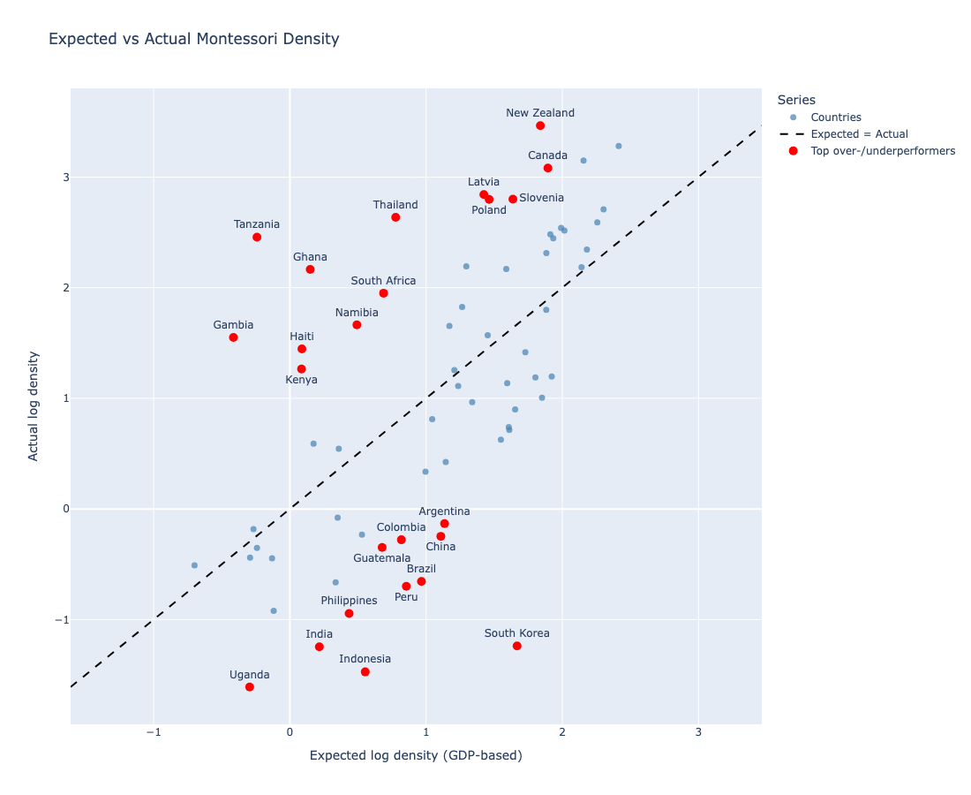
Figure 3 Expected versus actual Montessori density based on a GDP-only benchmark model. The diagonal line represents the level at which observed Montessori density matches the value predicted by GDP per capita. Countries above the line exhibit higher Montessori density than expected, whereas countries below the line exhibit lower density than expected. Highlighted countries are those with large positive or negative residuals, indicating substantial deviation from structural expectations.

Among overperformers, several countries with favorable socio-economic conditions, such as Canada, Poland, Latvia, and Slovenia, exhibit substantially higher Montessori density than predicted. These cases suggest that, in structurally supportive environments, Montessori education can expand beyond expected levels, possibly due to favorable institutional conditions, established teacher training infrastructure, or strong national networks that facilitate diffusion.

At the same time, a number of lower-income countries, including Ghana, Tanzania, Kenya, and Haiti, also show strong relative performance. In these contexts, Montessori diffusion appears to follow a different pattern. Rather than being driven primarily by broad-based economic capacity, it may reflect niche dynamics supported by non-profit organizations, international Montessori networks, or faith-based educational initiatives. Such actors can enable the establishment of Montessori schools independently of local income levels, leading to relatively high density even in structurally constrained environments.

In contrast, underperformers include several large and economically significant countries, such as South Korea, Brazil, India, and China, where Montessori density remains substantially below expected levels. These cases indicate that structural capacity alone is not sufficient to ensure Montessori diffusion. Institutional factors, including the organization of national education systems, regulatory environments, or cultural attitudes toward alternative pedagogies, may limit adoption even where economic development and human capital are relatively high.Taken together, these findings reinforce the interpretation of Montessori diffusion as a context-dependent and stage-dependent process. While economic development and human capital provide the structural foundation for diffusion, they do not fully determine outcomes. In early-stage or resource-constrained contexts, Montessori education may emerge through niche mechanisms driven by specific actors or networks. In more developed contexts, diffusion appears to depend on broader societal conditions, including the size and capacity of the middle class and the institutional environment.

This perspective helps explain both the strong overall associations observed in the previous section and the substantial cross-country variation that remains. The comparison between expected and observed diffusion thus provides a useful lens for identifying countries that merit further investigation and for highlighting the diversity of pathways through which Montessori education spreads globally.

Author Information
Saša Lapter is member of the board at European Forum for Freedom in Education - Austrian Chapter. He can be reached at sasa.lapter@effe.at.
https://orcid.org/0009-0002-7136-2861

References
Debs, M. C., de Brouwer, J., Murray, A. K., Lawrence, L., Tyne, M., & von der Wehl, C. (2022). Global Diffusion of Montessori Schools: A Report from the 2022 Global Montessori Census. Journal of Montessori Research, 8(2), 1-15. https://doi.org/10.17161/jomr.v8i2.18675
In [ ]:

